KRASSOTA PANEURHYTHMY RETREAT 2010

IDEAL-SPRING INTERNATIONAL FOUNDATION

invites you to participate in our annual retreat,
June 30 - July 7, 2010 at Krassota in Victor, Montana
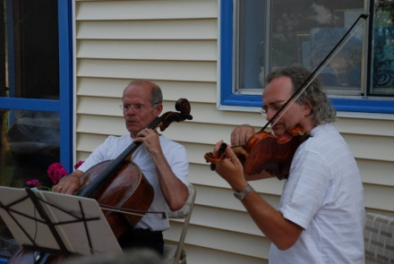

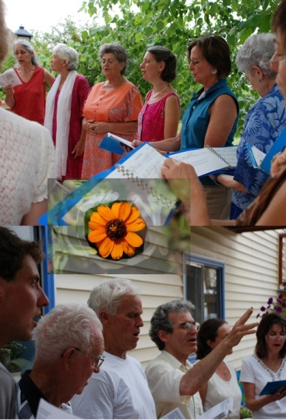
“When we are talking of wise and living Nature, we mean one of the greatest beings after God. Nature contains everything in its aura. It is bright, wise, gentle and pure. It contains Love within itself.”
Beinsa Douno

We are delighted to invite you & your friends to our week-long annual Retreat at Krassota. We will join Dr. Natacha Kolesar, Ardella Nathanael, Amy Kraft, Gilles Hainault, and others from I.D.E.A.L. (Institute for the Development of Education, Arts, and Leisure). There will be music, both singing and dancing PanEuRhythmy, art, lectures by Dr. Kolesar, yoga for all ages & physical abilities, therapeutics, excursions into the beautiful natural surroundings, sharing the communal life-style so beautifully inaugurated by Peter Deunov in the Izgrev Community & MORE…. Those of you who know the I.D.E.A.L. Community (http://www.idealsociety.org/) will jump for joy at the prospect of being with them again.
2 SPECIAL WORKSHOPS: June 27—29. For more info and to reserve a place, please e-mail Amy asap! YOGA & THERAPEUTICS: July 7-9!
“Krassota” is Bulgarian for “beauty”. And the qualities of the environment at and around Krassota, a mountainous and pristine region, have been compared favorably to those of the Rila Mountains. we aspire to draw closer to the spring of Divine Love.


“To go to the Mussala peak symbolically means to go to God.”
Beinsa Douno
The Sacred PanEuRhythmy Dances of Peter Deunov (Beinsa Douno) give us a joyful spiritual practice and a personal experience of unity. The first 28 movements awaken us to our own potential and help us to develop and harmonize heart, mind, soul and spirit.
The SUNBEAMS, with its beautiful hymn to Mother Earth, coaxes our budding spirit to blossom.
The PENTAGRAM symbolizes the evolution of the human soul toward Divine perfection. As we dance, we embody the Pentagram of Love, Wisdom, Truth, Justice and Goodness.


THE RETREAT SETTING
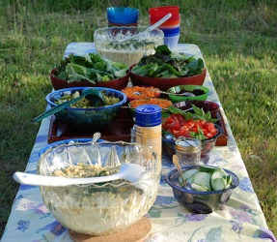
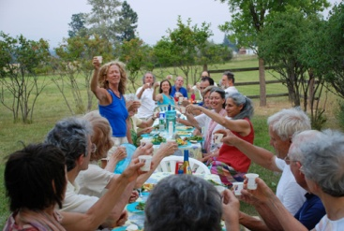

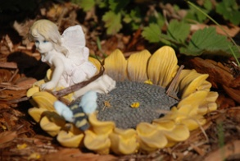
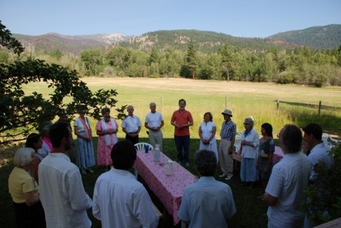
Amy Kraft has provided a choice of lodging, which will vary according to people's needs and desires. There will be beds in the main house at Krassota in single, double, or multiple rooms, as well as camping in the grounds, and single or double rooms at nearby guest houses. Delicious vegetarian meals will be prepared and served. The house has a wonderful deck from which to view breathtaking sunrises over the Bitterroot valley and far-distant mountains to the East; and each morning we will dance PanEuRhythmy in the beautiful grounds. There are trails and rivers close by. There is a lovely lake about 45 minutes away. Registration information is attached.

CONTACT INFORMATION: Amy: 406-546-6922 (after March 4th),amykrft@yahoo.com/ Ardella Nathanael:415-499-8027,ardella22@yahoo.com
Websites: www.everabooks.com | www.paneurhythmy.us

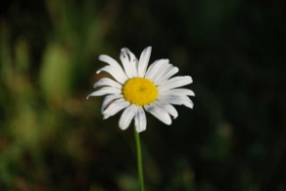
“Divine Love is great Spring. It is always fresh.”
Beinsa Douno

